Platform Management Committee-EHRC CSO Coordination Platform
Platform Management Committee Members
 |   Chair- Ethiopian Human Rights Commission | 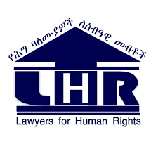
General  EHRC-CSO Coordination Platform | Chair- Ethiopian Human Rights Commission | Co-chair- Lawyers for Human Rights (LHR_
General  EHRC-CSO Coordination Platform |  | Deputy Co-chair-Ethiopian Women Lawyers’ Association (EWLA)
Women and Children Rights Sub-Thematic Group |  | 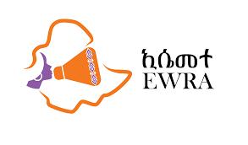  Co-Chair: Ethiopian Women's Rights Advocates (EWRA)
Disability and Older Persons’ Rights |  |   Co-Chair: Ethiopian National Association of the Blind (ENAB)
Human Rights Monitoring and Investigation |  | 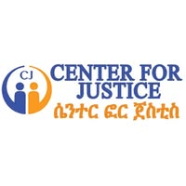
Transitional Justice |  | 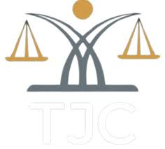
Human Rights Education
IDPs, Refugees, and Migrants' Rights

